CONTROL STATEMENTS
Name : Sreya Sudheeran
Mis : 612303175
Div : 2
Batch : S4

1.#include <stdio.h>
int main()
{
int i = 1024;
for (; i; i >>= 1)
printf("HelloWorld");
return 0;
}
How many times will HelloWorld be printed in the above program?
Ans : Hello World will be printed 11 times
2.#include <stdio.h>
int main()
{
int i = 0;
switch (i)
{
case '0': printf("Hello");
break;
case '1': printf("World");
break;
default: printf("HelloWorld");
}
return 0;
}
Ans : HelloWorld
3.#include <stdio.h>
int main()
{
int i = 3;
switch (i)
{
case 0+1: printf("Hello");
break;
case 1+2: printf("World");
break;
default: printf("HelloWorld");
}
return 0;
}
Ans : World
4. #include <stdio.h>
#define EVEN 0
#define ODD 1
int main()
{
int i = 3;
switch (i & 1)
{
case EVEN: printf("Even");
break;
case ODD: printf("Odd");
break;
default: printf("Default");
}
return 0;
}
Ans : Odd
5.#include <stdio.h>
int main()
{
int i;
if (printf("0"))
i = 3;
else
i = 5;
printf("%d", i);
return 0;
}
Ans: 3

6.#include <stdio.h>
int i;
int main()
{
if (i);
else
printf("Else");
return 0;
}
Ans : Else
7.#include<stdio.h>
int main()
{
int n;
for (n = 9; n!=0; n--)
printf("n = %d", n--);
return 0;
}
Ans : n = 9n = 7n = 5n = 3n = 1
8. #include <stdio.h>
int main()
{
int c = 5, no = 10;
do {
no /= c;
} while(c--);
printf ("%d\n", no);
return 0;
}
Ans: 0

9.# include <stdio.h>
int main()
{
int i = 0;
for (i=0; i<20; i++)
{
switch(i)
{
case 0:
i += 5;
case 1:
i += 2;
case 5:
i += 5;
default:
i += 4;
break;
}
printf("%d ", i);
}
return 0;
}
Ans: 16 21

10. #include<stdio.h>
int main()
{
int i = 0;
for (printf("1st\n"); i < 2 && printf("2nd\n"); ++i &&
printf("3rd\n"))
{
printf("*\n");
}
return 0;
}
Ans:
1st
2nd
3rd
*
2nd
3rd
*

11.#include <stdio.h>
int main()
{
int i;
for (i = 1; i != 10; i += 2)
printf(" HelloWorld ");
return 0;
}
Ans: HelloWorld HelloWorld HelloWorld HelloWorld HelloWorld
12.char inchar = 'A';
switch (inchar)
{
case 'A' :
printf ("choice A n") ;
case 'B' :
printf ("choice B ") ;
case 'C' :
case 'D' :
case 'E' :
default:
printf ("No Choice") ;
}

Ans: choice A n choice B No Choice

13. #include <stdio.h>
int main()
{
int i = 3;
switch(i)
{
printf("Outside ");
case 1: printf("Hello");
break;
case 2: printf("World");
break;
defau1t: printf("HelloWorld");
}
return 0;
}
Ans: --No output --
14.#include <stdio.h>
int main()
{
char check = 'a';
switch (check)
{
case 'a' || 1: printf("Hello ");
case 'b' || 2: printf("World ");
break;
default: printf("HelloWorld");
}
return 0;
}

Ans: HelloWorld
15.#include <stdio.h>
int main()
{
int check = 20, arr[] = {10, 20, 30};
switch (check)
{
case arr[0]: printf("Hello ");
case arr[1]: printf("World ");
case arr[2]: printf("HelloWorld");
}
return 0;
}
Ans: World HelloWorld

16. #include<stdio.h>
int main()
{
int i = -5;
while (i <= 5)
{
if (i >= 0)
break;
else
{
i++;
continue;
}
printf("HelloWorld");
}
return 0;
}
Ans: --NO OUTPUT--

17. #include <stdio.h>
int main()
{
int i = 3;
while (i--)
{
int i = 100;
i--;
printf("%d ", i);
}
return 0;
}

Ans: 99 99 99
18.#include <stdio.h>
int main()
{
int x = 3;
if (x == 2); x = 0;
if (x == 3) x++;
else x += 2;
printf("x = %d", x);
return 0;
}

Ans: x = 2

19.#include<stdio.h>
int main()
{
int a = 5;
switch(a)
{
default:
a = 4;
case 6:
a--;
case 5:
a = a+1;
case 1:
a = a-1;
}
printf("%d n", a);
return 0;
}
Ans: 5

20.#include "stdio.h"
int main()
{
int i = 1, j;
for ( ; ; )
{
if (i)
j = --i;
if (j < 10)
printf("HelloWorld", j++);
else
break;
}
return 0;
}
Ans: HelloWorldHelloWorldHelloWorldHelloWorldHelloWorldHelloWorldHelloWorldHelloWorldHelloWorldHelloWorld

21.#include "stdio.h"
int main()
{
int j = 0;
for ( ; j < 10 ; )
{
if (j < 10)
printf("Hello", j++);
else
continue;
printf(“World”);
}
return 0;
}
Ans: HelloWorldHelloWorldHelloWorldHelloWorldHelloWorldHelloWorldHelloWorldHelloWorldHelloWorld
22.#include <stdio.h>
int main()
{
unsigned int i = 65000;
while (i++ != 0);
printf("%d", i);
return 0;
}
Ans: 1

23.#include <stdio.h>
int main()
{
int i;
for ( i=0; i<5; i++ )
{
int i = 10;
printf ( "%d ", i );
i++;
}
return 0;
}
Ans: 10 10 10 10 10
Programming Assignment
1.Write a program to read 10 integers. Display these numbers by printing three
numbers in a line separated by commas.
Ans:
#include <stdio.h>
#define SIZE 10

int main(){
int arr[SIZE];
for (int i = 0; i < 10; i++){
scanf("%d", &arr[i]);
}
int a = 0;
for (int i = 0; i < 10; i = i+3){
for (int j = 0; j < 2 && a < 9; j++){
printf("%d,", arr[a]);
a++;
}
printf("%d\n", arr[a]); /*prints newline after three elements*/
a++;
}
}
Output
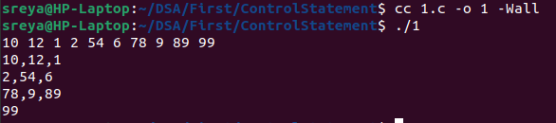
2. Write a program to print the count of even numbers between 1–200. Also print their
sum.
Ans:
#include <stdio.h>

int main(){
int even = 0;
int sum = 0;
for(int i = 1; i < 201; i++){
if(i % 2 == 0){ /*sees if the number is even or not */
even++;
sum = sum + i;
}
}
printf("%d %d\n", sum, even);
}

Output
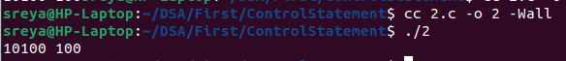
3. Write a program to count the number of vowels in a text. (eg: Enter text: hello world,
Output: No.of vowels- 3 ).
Ans:
#include <stdio.h>

int main() {
int c;
int count = 0;
while ((c = getchar()) != EOF) {
if (c == 'a' || c == 'e' || c == 'i' || c == 'o' || c == 'u' ||c == 'A' || c == 'E' || c == 'I' || c == 'O' || c == 'U') { /*counts the number of vowels */
count++;
}
}
printf("\nNumber of vowels: %d\n", count);
return 0;
}

Output
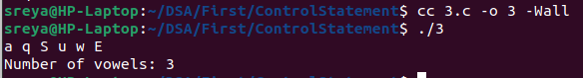
4. Write a program to read two floating point numbers. Add these numbers and assign
the result to an integer. Finally, display the value of all the three variables.
Ans:
#include <stdio.h>

int main() {
float num1, num2;
int sum;
scanf("%f", &num1);
scanf("%f", &num2);
sum = (int)(num1 + num2);
printf("%.2f\n", num1);
printf("%.2f\n", num2);
printf("%d\n", sum);
return 0;
}
Output

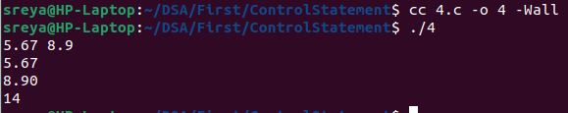
5. Write a program to read a floating point number. Display the rightmost digit of the
integral part of the number.

Ans:
#include <stdio.h>

int main(){
float num;
int ans;
scanf("%f", &num);
ans = (int) num;
int val = ans % 10;
printf("%d\n", val);
return 0;
}

Output

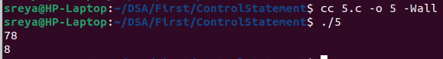
6. Write a program to calculate simple interest and compound interest.
Ans:
#include <stdio.h>
#include <math.h> /*to use pow function*/

int main() {
float principal, rate, time;
float simpleInterest, compoundInterest;
scanf("%f", &principal);
scanf("%f", &rate);
scanf("%f", &time);
simpleInterest = (principal * rate * time) / 100.0;
float amount = principal * pow((1 + rate / 100.0), time);
compoundInterest = amount - principal;
printf("Simple Interest: %.2f\n", simpleInterest);
printf("Compound Interest: %.2f\n", compoundInterest);
return 0;
}

Output
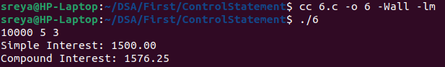
7.Write a program to calculate salary of an employee given his basic pay (to be
entered by the user), HRA = 10% of the basic pay, TA = 5% of basic pay. Define
HRA and TA as constants and use them to calculate the salary of the employee.
Ans:
#include <stdio.h>
#define HRA 0.10
#define TA 0.05

int main() {
float basicPay, salary;
float hra, ta;
scanf("%f", &basicPay);
hra = HRA * basicPay;
ta = TA * basicPay;
salary = basicPay + hra + ta;
printf("Total Salary: %.2f\n", salary);

return 0;
}

Output

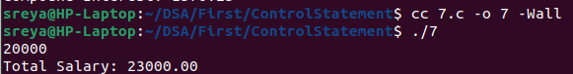
8. Write a program to prepare a grocery bill. Enter the name of the items purchased,
quantity in which it is purchased, and its price per unit. Then display the bill in the
following format:
************ ********************************B I L L *****************************************
Item Quantity Price Amount
__________________________________________________________________
Total Amount to be paid =
__________________________________________________________________

Ans:
#include <stdio.h>

int main() {
char item[100][100];
int quantity[100];
float price[100], amount[100];
int n;
printf("Enter the number of items: ");
scanf("%d", &n);
float totalAmount = 0.0;
for (int i = 0; i < n; i++) {
printf("Enter item %d:\n", i + 1);
printf("Item name: ");
scanf(" %[^\n]s", item[i]);
printf("Quantity: ");
scanf("%d", &quantity[i]);
printf("Price: ");
scanf("%f", &price[i]);
amount[i] = quantity[i] * price[i];
totalAmount += amount[i];
}
printf("\n*** Bill ***\n");
printf("Item Quantity Price Amount\n");
for (int i = 0; i < n; i++) {
printf("%-10s %-8d %-7.2f %-7.2f\n", item[i], quantity[i], price[i], amount[i]);
}
printf("Total Amount: %.2f\n", totalAmount);
return 0;
}

Output

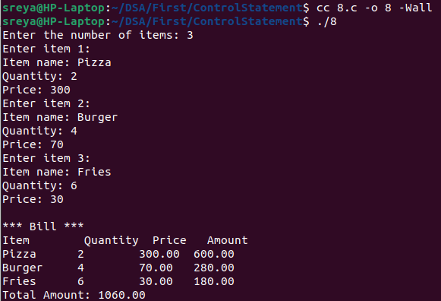

9. Write a program to read an integer. Display the value of that integer in decimal,
octal, and hexadecimal notation.
Ans:
#include <stdio.h>
int main(){
int a;
scanf("%d", &a);
printf("%o\n", a);
printf("%d\n", a);
printf("%x\n", a);
}
Output

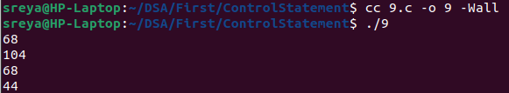
10. Write a program that prints a floating point value in exponential format with the
following specifications:
a. correct to two decimal places;
b. correct to four decimal places; and
c. correct to eight decimal places.
[Expected Output: value entered: 123456.453125 Value in exponent
form: 1.234565e+05 ]
Ans:
#include <stdio.h>
int main() {
float num;
printf("Enter a floating-point value: ");
scanf("%f", &num);
printf("Value entered: %.6f\n", num);
printf("Value in exponent form : %.2e\n", num);
printf("Value in exponent form : %.4e\n", num);
printf("Value in exponent form : %.8e\n", num);
return 0;
}

Output

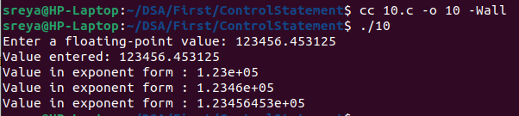
11. Write a program to read a character and print it. Also print its ASCII value. If the
character is in lower case, print it in upper case and vice versa. Repeat the process
until a ‘*’ is entered.
Ans:
#include <stdio.h>

int main() {
char ch;
while ((ch = getchar()) != '*') {
while (getchar() != '\n');
printf("Character entered: %c\n", ch);
printf("ASCII value: %d\n", ch);
if (ch >= 'a' && ch <= 'z') {
printf("Uppercase conversion: %c\n", ch - 32);
} else if (ch >= 'A' && ch <= 'Z') {
printf("Lowercase conversion: %c\n", ch + 32);
}
}
return 0;
}

Output

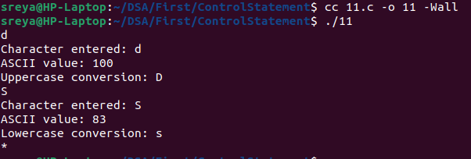
12.Write a program to add three floating point numbers. The result should contain
only two digits after the decimal.
Ans:
#include <stdio.h>

int main() {
float num1, num2, num3, sum;
scanf("%f", &num1);
scanf("%f", &num2);
scanf("%f", &num3);
sum = num1 + num2 + num3;
printf("%.2f\n", sum);
return 0;
}
Output
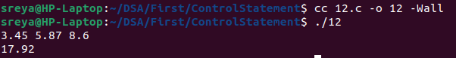
13. Write a program to take input from the user and then check whether it is a
number or a character. If it is a character, determine whether it is in upper case or
lower case. Also print its ASCII value
Ans:
#include <stdio.h>

int main() {
char ch;
scanf("%c", &ch);

if (ch >= '0' && ch <= '9') {
printf("Input '%c' is a number.\n", ch);
}
else if ((ch >= 'a' && ch <= 'z') || (ch >= 'A' && ch <= 'Z')) {
printf("Input '%c' is a character.\n", ch);
if (ch >= 'a' && ch <= 'z') {
printf("It is in lowercase.\n");
printf("Uppercase conversion: %c\n", ch - 32);
}
else {
printf("It is in uppercase.\n");
printf("Lowercase conversion: %c\n", ch + 32);
}
}
else {
printf("Invalid input: '%c'\n", ch);
}
printf("ASCII value: %d\n", ch);
return 0;
}
Output

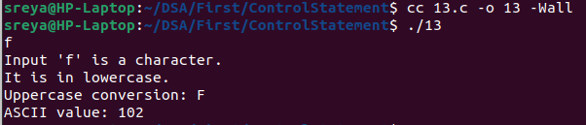
14.Write a program to display sum and average of numbers from 1 to n. Use for
loop.
Ans:
#include <stdio.h>

int main() {
int n, sum = 0;
float average;
scanf("%d", &n);
for (int i = 1; i <= n; ++i) {
sum += i;
}
average = (float)sum / n;
printf("Sum: %d\n", sum);
printf("Average : %.2f\n", average);
return 0;
}
Output

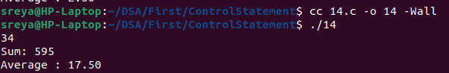
15. Write a program to print all odd numbers from m to n.
Ans:
#include <stdio.h>

int main() {
int m, n;
scanf("%d", &m);
scanf("%d", &n);
if (m > n) {
int temp = m;
m = n;
n = temp;
}
for (int i = m; i <= n; ++i) {
if (i % 2 != 0) {
printf("%d\n", i);
}
}

return 0;
}

Output

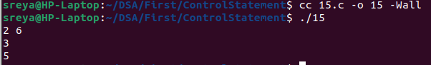
16. Write a program to print all prime numbers from m to n.
Ans:
#include <stdio.h>

int prime(int num) {
if (num <= 1) {
return 0;
}

for (int i = 2; i * i <= num; i++) {
if (num % i == 0) {
return 0;
}
}

return 1;
}

int main() {
int m, n;
scanf("%d %d", &m, &n);
if (m < 2) {
m = 2;
}
for (int i = m; i <= n; i++) {
if (prime(i)) {
printf("%d\n", i);
}
}

return 0;
}

Output

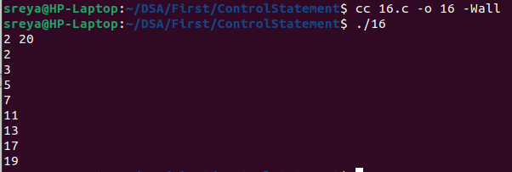
17. Write a program to read numbers until –1 is entered and display whether it is
an Armstrong number or not.

Ans: #include <stdio.h>
#include <math.h>

int digits(int num) {
int count = 0;
while (num != 0) {
num /= 10;
count++;
}
return count;
}

int armstrong(int num) {
int originalNum = num;
int numDigit = digits(num);
int sum = 0;

while (num != 0) {
int digit = num % 10;
sum += pow(digit, numDigit);
num /= 10;
}

return (sum == originalNum);
}

int main() {
int number;
while ((scanf("%d", &number)) != -1){
if (armstrong(number)) {
printf("%d is an Armstrong number.\n", number);
} else {
printf("%d is not an Armstrong number.\n", number);
}
}

return 0;
}

Output
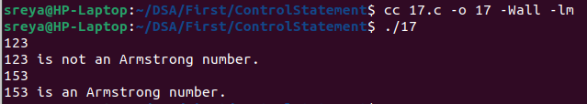
18. The wind chill index (WCI) is calculated from the wind speed v in miles per hour
and the temperature t in Fahrenheit. Three formulas are used, depending on the
wind speed:
if (0 <= v <= 4) then WCI = t
if (v >=45) then WCI = 1.6t - 55
otherwise, WCI = 91.4 + (91.4 - t)(0.0203v - 0.304(v)1/2 - 0.474).
Write a program that can calculate the wind chill index
Ans:
#include <stdio.h>
#include <math.h>

int main() {
float v, t, wci;
scanf("%f", &v);
scanf("%f", &t);
if (v >= 0 && v <= 4) {
wci = t;
}
else if (v >= 45) {
wci = 1.6 * t - 55;
}
else {
wci = 91.4 + (91.4 - t) * (0.0203 * v - 0.304 * sqrt(v) - 0.474);
}
printf("Wind Chill Index: %.2f\n", wci);
return 0;
}
Output
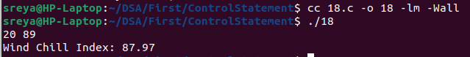
19. Write a program that asks the user to enter an integer and determines whether
it is divisible by 5 and 6, whether it is divisible by 5 or 6, and whether it is divisible
by 5 or 6 but not both. For example, if your input is 10, the output should be:
Is 10 divisible by 5 and 6? false
Is 10 divisible by 5 or 6? true
Is 10 divisible by 5 or 6, but not both? True
Ans:
#include <stdio.h>

int main() {
int num;
printf("Enter an integer: ");
scanf("%d", &num);
if ((num % 5 == 0) && (num % 6 == 0)) {
printf("Is %d divisible by 5 and 6? true\n", num);
}
else {
printf("Is %d divisible by 5 and 6? false\n", num);
}
if ((num % 5 == 0) || (num % 6 == 0)) {
printf("Is %d divisible by 5 or 6? true\n", num);
}
else {
printf("Is %d divisible by 5 or 6? false\n", num);
}
if ((num % 5 == 0) != (num % 6 == 0)) {
printf("Is %d divisible by 5 or 6, but not both? true\n", num);
}
else {
printf("Is %d divisible by 5 or 6, but not both? false\n", num);
}
return 0;
}
Output
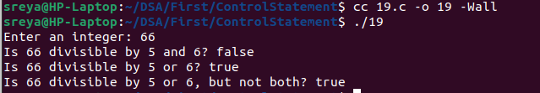
20. McDonald’s wants you to write a program to take orders from the Internet. Your
program asks for the item, its price, and if overnight shipping is wanted. Regular
shipping for items under Rs.100 is Rs20.00; for items Rs100 or more shipping is
Rs30.00. For overnight delivery add Rs50.00. For example, the output might be:
Enter the item: Burger Enter the price: 450 Overnight delivery (0==no, 1==yes): 1
Invoice: Burger Rs.450 shipping Rs.80 total Rs. 530.
Ans:
#include <stdio.h>

int main() {
char item[100];
float price;
int delivery;
float shipping;
float total;
printf("Enter the item : ");
scanf(" %[^\n]", item);
printf("Enter the price : ");
scanf("%f", &price);
printf("Overnight delivery (0==no, 1==yes): ");
scanf("%d", &delivery);
if (price < 100) {
shipping = 20.00;
}
else {
shipping = 30.00;
}
if (delivery == 1) {
shipping += 50.00;
}
total= price + shipping;
printf("Invoice: %s Rs.%.2f shipping Rs.%.2f total Rs. %.2f\n", item, price, shipping, total);
return 0;
}
Output
